Objectives

In these trying times more than ever, being able to keep ourselves healthy and active without leaving the comfort of our homes is essential, although is not always easy. This project might be an additional handy tool for making us momentarily forget the urge to go outside by making our indoor life a little bit more pleasant. RemyTutor is a remote learning platform for anything people might want to teach and transmit to other learning enthusiasts. Ranging from school subjects, like math or history, to more practical things, like yoga or a musical instrument, just find the right teacher and book a lesson!

When it comes to teaching, finding the right person, or even finding someone, can be a challenging task and might often feel like a Russian roulette. Therefore, our goal is to provide an online safe space to bring supply and demand together in a structured way, to ease the flow of teaching and improve its overall quality.

Main functionalities

In order to meet the objectives, RemyTutor offers the following functionalities:

* Searching the subjects of interest;
* Choosing the teacher based on their rating and price;
* Managing personal profile;
* Asking/proposing the lessons with the chat included in the application;
* Rating a teacher after a lesson;
* Payment from the student to the teacher.

Design choices

Lorem ipsum dolor sit amet, consectetur adipiscing elit. Etiam lacinia scelerisque euismod. Quisque rhoncus feugiat nisl. Pellentesque finibus feugiat tellus. Praesent in sodales lorem, et aliquam elit. Vivamus bibendum in mauris sodales lacinia. Donec et elementum justo. Praesent eget mauris consectetur, luctus massa vel, maximus ipsum. Sed quis quam sit amet magna congue tincidunt. Vivamus vel tortor eros. Nulla massa lacus, maximus quis orci quis, tristique cursus nisl.

Homepage

This page main purpose is to channel the user through our service, and this is done by showing a search bar where he can immediately access the platform and browse available teachers, even without a registered account. This will be of course required in a second time when the user picks a teacher and decides to book a lesson. This page also hosts a slideshow that sums up all the opportunity our platform offers, to encourage users to join the team! The slideshow is implemented from scratch with pure Vanilla JS and it has a sliding animation effect powered by CSS3 transitions. It also scales responsively with the page and offers an infinite images loop. The search bar is equipped with an autocompletion/suggestions box powered by jQuery UI that lists all the offered lesson topics. From here it is possible to access the sign in or sign up interface described later.

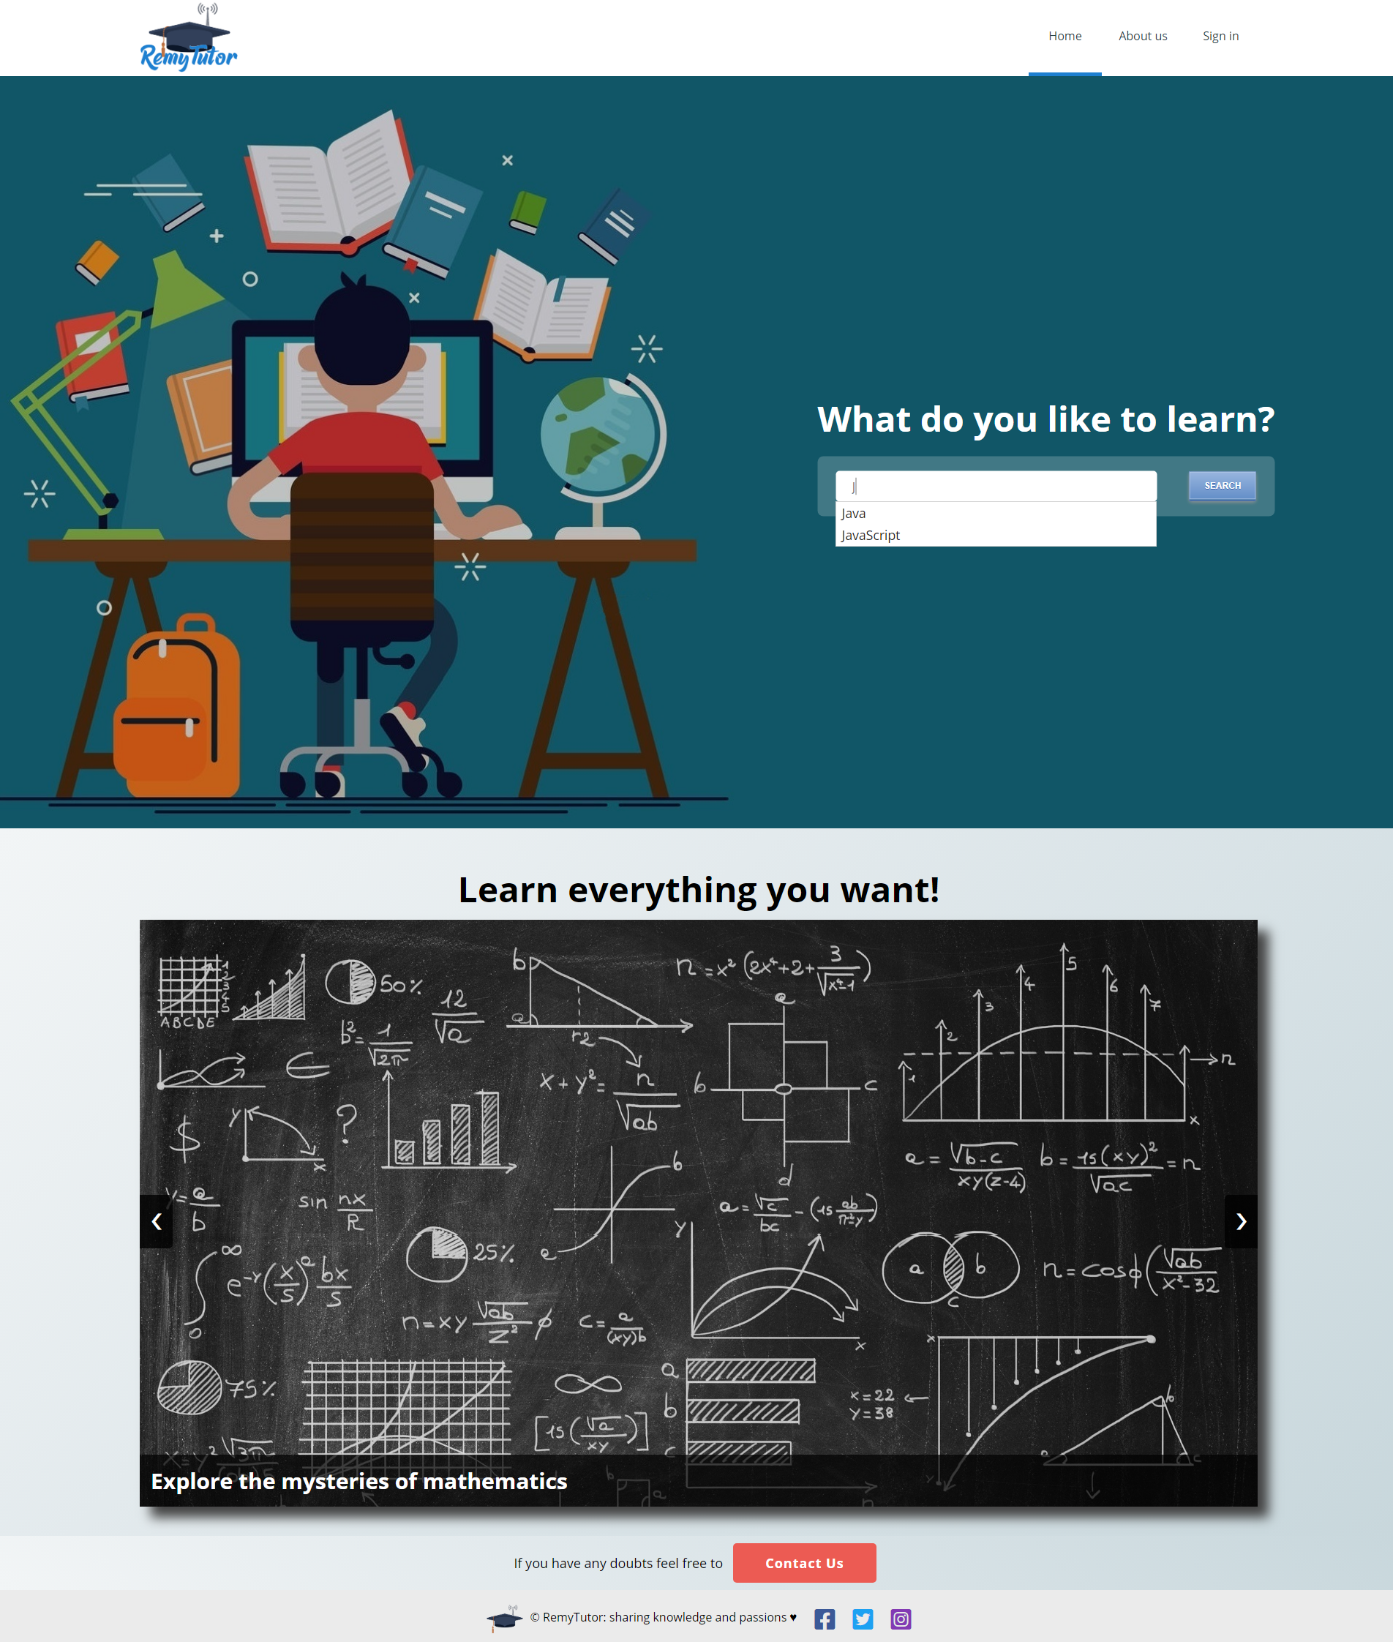

Search Interface

The name itself pretty much explain the purpose of this page. It is a common search page that offers the possibility of sorting results by average feedback rate and teacher’s tariff. Again, also from here is possible to access the sign up/in interface.

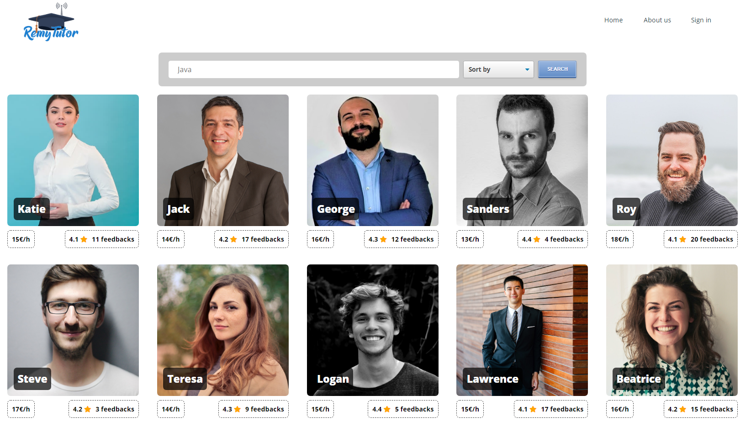

Teacher page

This is the page the user is presented when he picks a teacher in the search page. It contains the teacher’s presentation that he writes himself on the profile dashboard page. He can write whatever he wants but of course it should be aimed at winning the student’s trust and convincing him that he is the right one. At the bottom, the teacher previous student’s feedbacks are shown to prove teacher’s reliability, or lack thereof. In the upper part, a button is prepared for sending a request to the teacher that he can either accept of reject. It is at this point that, to perform this operation, an account is required.

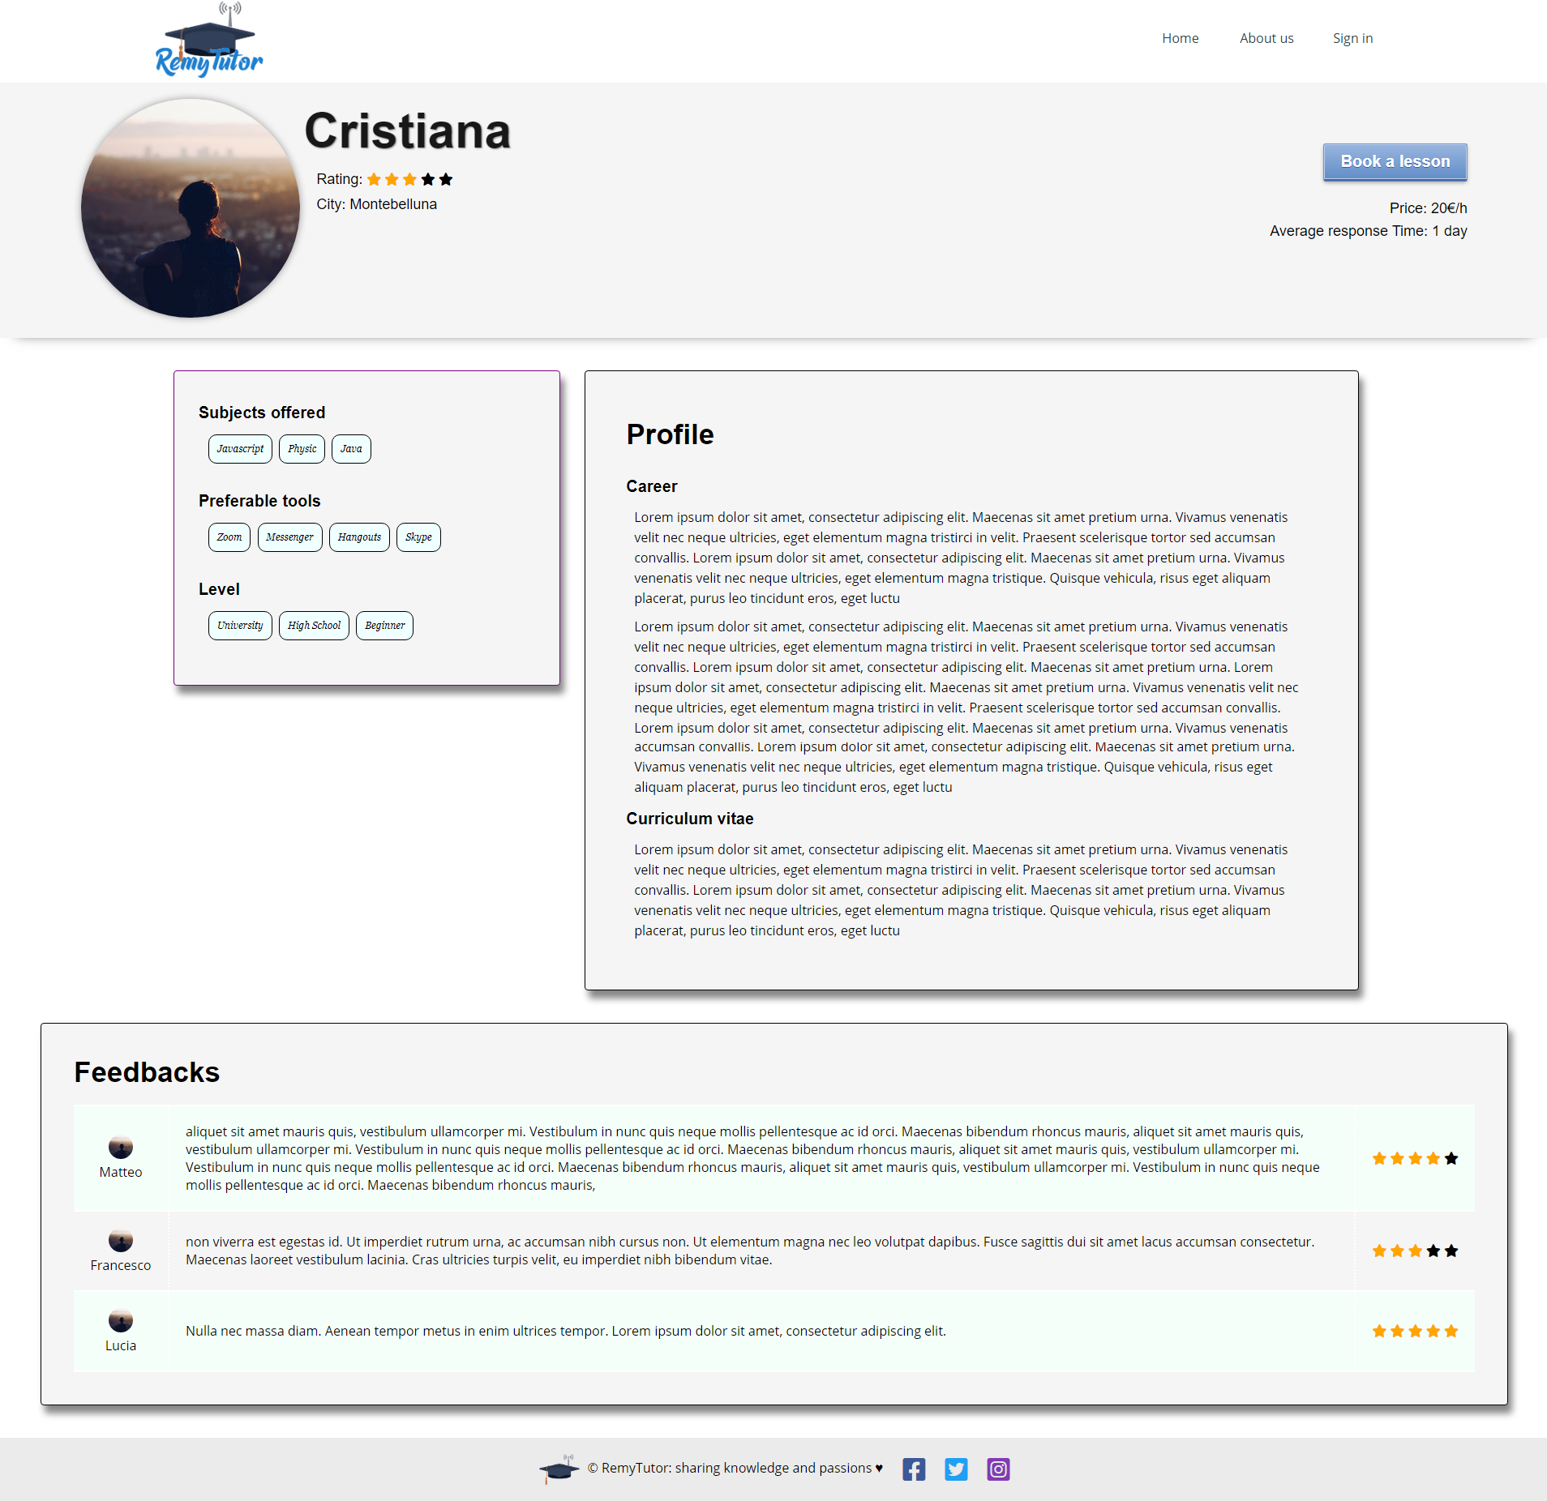

Sign up/in Interface

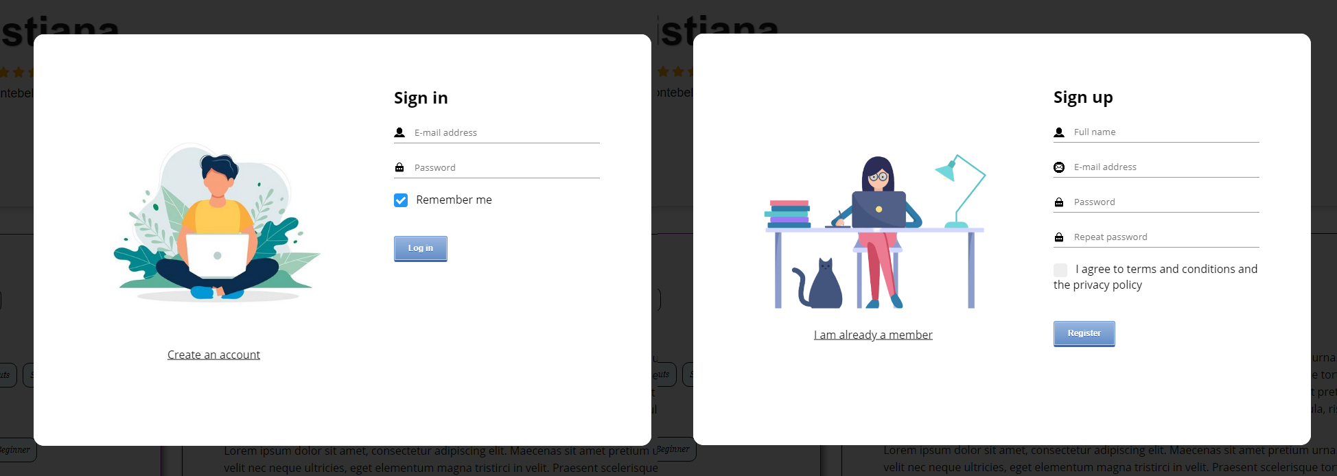

This interface appears as a modal on top of the page we are browsing, and it consists of a two-faced card with a flipping animation effect between the two, triggered by the link on the left side of each face.

When a sign in request is issued, an AJAX call to the server will be performed with the following very simple JSON data format:

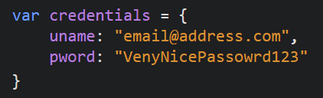

The security of this operation is not a problem at all, since the server can easily be equipped with a certificate, therefore it is possible to switch to the HTTPS protocol so the data will be automatically encrypted. On the sign-up face instead, the form is validated and only in case everything is fine the form is sent through a standard POST HTTP request to the server, which will re-validate the data and create the new user account.

About us

Lorem ipsum dolor sit amet, consectetur adipiscing elit. Etiam lacinia scelerisque euismod. Quisque rhoncus feugiat nisl. Pellentesque finibus feugiat tellus. Praesent in sodales lorem, et aliquam elit. Vivamus bibendum in mauris sodales lacinia. Donec et elementum justo. Praesent eget mauris consectetur, luctus massa vel, maximus ipsum. Sed quis quam sit amet magna congue tincidunt. Vivamus vel tortor eros. Nulla massa lacus, maximus quis orci quis, tristique cursus nisl.

Dashboard

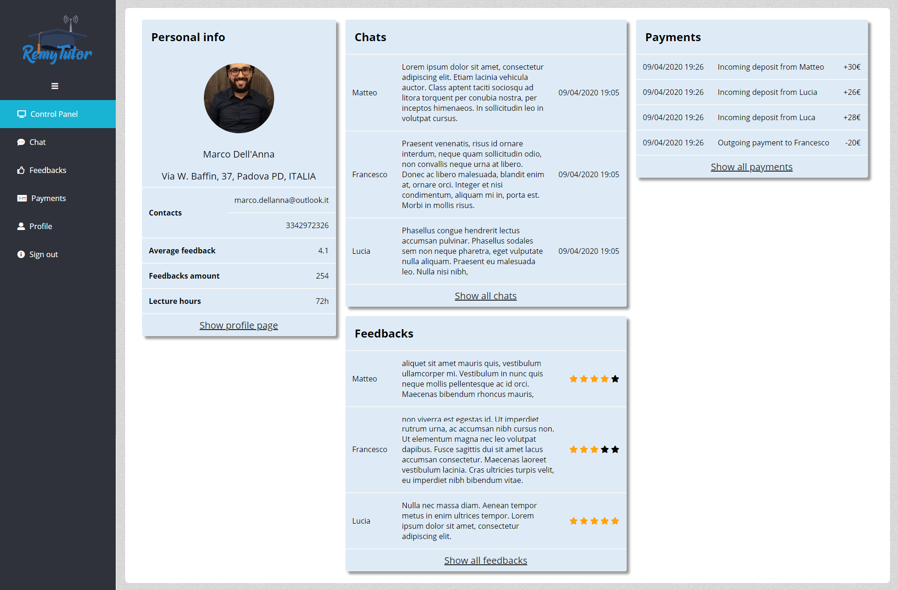

|  |  |
| --- | --- |
|  | The dashboard main page is simply a condensed version of all the other detailed pages. Here only the most recent items of each other page are shown, together with a box containing the user’s main personal information. The user can be redirected to the specific page through the navigation bar or a link at the bottom of each box. The navigation bar is shared among all the dashboard pages and it has been made collapsible in order to offer more space as needed. |

Login



Lorem ipsum dolor sit amet, consectetur adipiscing elit. Etiam lacinia scelerisque euismod. Quisque rhoncus feugiat nisl. Pellentesque finibus feugiat tellus. Praesent in sodales lorem, et aliquam elit. Vivamus bibendum in mauris sodales lacinia. Donec et elementum justo. Praesent eget mauris consectetur, luctus massa vel, maximus ipsum. Sed quis quam sit amet magna congue tincidunt. Vivamus vel tortor eros. Nulla massa lacus, maximus quis orci quis, tristique cursus nisl.



Lorem ipsum dolor sit amet, consectetur adipiscing elit. Etiam lacinia scelerisque euismod. Quisque rhoncus feugiat nisl. Pellentesque finibus feugiat tellus. Praesent in sodales lorem, et aliquam elit. Vivamus bibendum in mauris sodales lacinia. Donec et elementum justo. Praesent eget mauris

Personal Profile

The profile page provides a complete editable view about user’s own main personal information. It includes also other useful information such as qualification and identity card. These are used as an optional identification mechanism since we base the main “reliability rate” on feedbacks. In this way there are not big entrance barriers, thus attracting a larger number of users, who can later base their choice on average feedbacks also by giving them the opportunity of sorting results by this value. Nevertheless, teachers might want to add this information to the profile in order to appear trustworthy towards students. Furthermore, all aforementioned information could be updated by the user by filling simple forms or uploading new files. In order to ensure the password strength, the new password should be at least six characters including upper/lowercases and numbers.

